Problem 4
Greatest common divisor
Level: Easy

Given unsigned integers a and b, find gcd(a,b), the greatest common divisor of a and b.
( 改成簡單的只求 gcd，則以下皆可省略。)
, according to the definition:
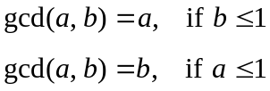 (Convention: 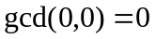)
More specific definition
Case 1:
a * b = 0 if a = 0 , gcd (a, b) = b
if b = 0, gcd ( a, b) = a
Case 2:
a * b ≠ 0 if a = 1, gcd ( a, b) = 1
if b = 1, gcd ( a, b) = 1

where 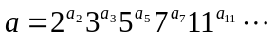 and 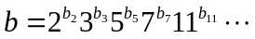 are prime factorizations of a and b, respectively.

Sample test
Input:
Filename: 4.in
Format: There are 10 lines to stand for 10 cases. Each line contains a set of a and b which separated with space.
Output:
Filename:
4.out
Format:
- For each case, the first line is a prompt as following: “case 1:”.
The next line is the answer.
- The last line of each case is an empty line.

Example:
Input:
0 0
0 1
2 0
4 6

Output:
case 1:
0

case 2:
1

case 3:
2

case 4:
2

